1. **Introductions and Session Overview.**
2. **Uses for Canvas as a Supplement to a Face-to-Face Course**

In face-to-face courses, you can use Canvas features to:

* Organize units of related materials that students can access from any device with an internet connection.
* Gather student work via online submissions in assignments, or deliver course content such as PDFs, documentation, and presentations using Files.
* Provide online practice quizzes or class surveys quickly and easily.

1. **Accessing the Site and Logging In.**

The Canvas login screen can be accessed in one of the following two ways:

* 1. Login to My Salve and click on the My Webcourses Quick Link on the right side of the portal.

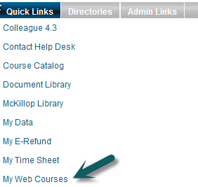

* 1. When the following screen appears enter your User Name and Password and click Log In:

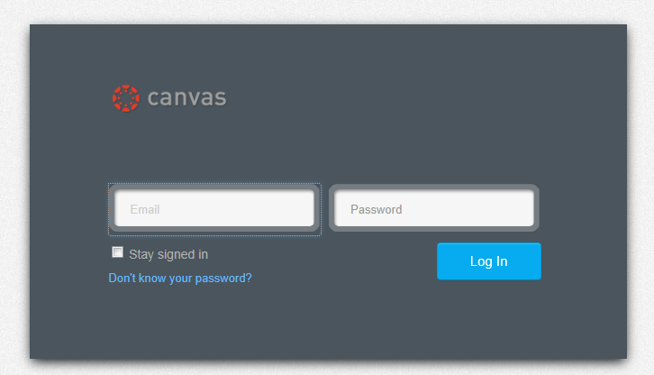

1. **The Dashboard and Global Navigation**

Once you have logged in you will see the Canvas Dashboard which offers a record of Recent Activity, easy access To Do items in each of your courses, and a Global Navigation Bar. The Dashboard helps you see what is happening in all your courses and allows you to figure out what to do next.

[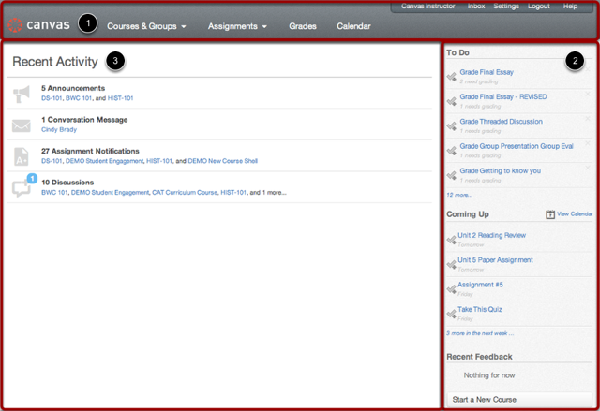](http://guides.instructure.com/s/2204/m/8472/l/40311-what-is-the-dashboard/show_image?image_id=2098707)

The Dashboard consists of three main elements:

1. Global Navigation across the top of the page,
2. The Sidebar with various types of feeds, and
3. The Global Stream, which comprises the main body of the page.﻿

The Dashboard is designed to answer the questions, "What is going on in all of my courses?" and "What do I need to do next?"

**Global Navigation**

[Global Navigation](http://guides.instructure.com/s/2204/m/8472/l/40311-what-is-the-dashboard/show_image?image_id=2098710)

The Global Navigation directs users to menus or pages that display:

1. all of a user's courses and groups,
2. all of a user's assignments,
3. a grade summary page, and
4. the Calendar.

These four menus and pages will display different items depending on whether you are a student or an instructor. Under Assignments, for example, Instructors will see assignments that need to be graded and students will see assignments that need to be turned in.

The Sidebar contains three helpful feeds:

1. The **To Do** feed lists the next five assignments you need to turn in (if you are a student) or you need to grade (if you are an instructor). Assignments will still show up in this list even if they are past due. Click on the links to go directly to the Assignments page.
2. The **Coming Up** feed lists the next five assignments or events coming due in the next week.
3. The **Recent Feedback** feed lets students know when their instructor has left a comment or a grade for one of their submissions. The same feed will let instructors know when students have left comments about work they have evaluated. This feed helps students and instructors keep the conversation alive around Assignments.

**Global Stream**

The Global Stream contains a stream of recent activity from all of your courses. There are announcements, discussions, assignment notifications, and conversations. This activity stream helps students and teachers to stay on top of what is going on in the course and allows them to easily ask questions and post to discussion forums. You can view the details of each section by hovering in the section area and clicking the **Show More** button.

[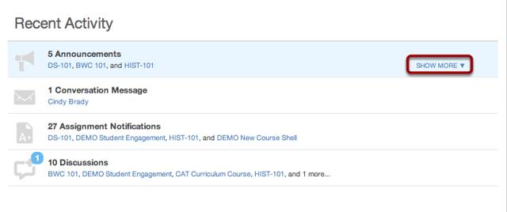](http://guides.instructure.com/s/2204/m/8472/l/40311-what-is-the-dashboard/show_image?image_id=2098716)

You can return to the Dashboard at any time by clicking on *canvas* on the upper left corner of the screen.

[](http://guides.instructure.com/s/2204/m/8472/l/40311-what-is-the-dashboard/show_image?image_id=2098719)

1. **Accessing and Changing Personal Settings**

Personal settings differ from course settings. To access your personal settings click on the Settings Link on the right upper corner of the screen.

[Locate Settings Link](http://guides.instructure.com/s/2204/m/8472/l/40327-how-do-i-access-my-personal-settings/show_image?image_id=2103024)

By clicking on the **Settings** link in the Help Corner of the Canvas interface, users can

* add a Profile picture
* change their display name
* adjust Notification Preferences
* upload Files
* create ePortfolios
* adjust user settings

Click the **Settings** link to open your personal settings. You will now be able to edit your personal settings.

[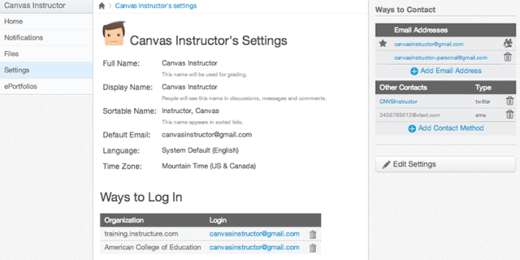](http://guides.instructure.com/s/2204/m/8472/l/73162-how-do-i-set-my-notification-preferences/show_image?image_id=2098961)

Before you can set your Notification Preferences, you will need to set the ways you want to be notified. Click the **Add Email Address** link to add additional emails to be contacted by [1]. Click the **Add Contact Method** link to add an SMS contact [2].

[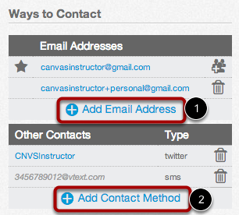](http://guides.instructure.com/s/2204/m/8472/l/73162-how-do-i-set-my-notification-preferences/show_image?image_id=2098964)

If you want to be contacted through Facebook or Twitter, you will need to link to those services. Register the external service by clicking the **[ServiceName]** button [1].

[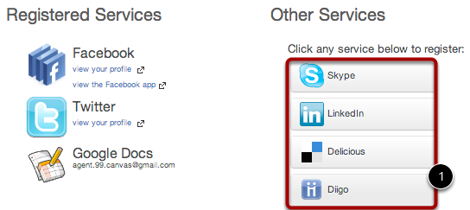](http://guides.instructure.com/s/2204/m/8472/l/73162-how-do-i-set-my-notification-preferences/show_image?image_id=2098967)

You are now ready to set your Notifications preferences. Click the **Notifications** link.

[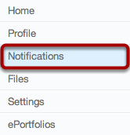](http://guides.instructure.com/s/2204/m/8472/l/73162-how-do-i-set-my-notification-preferences/show_image?image_id=2098970)

The notifications are divided up into six categories: You will need to go through and set how you want to be notified for each type of alert.

[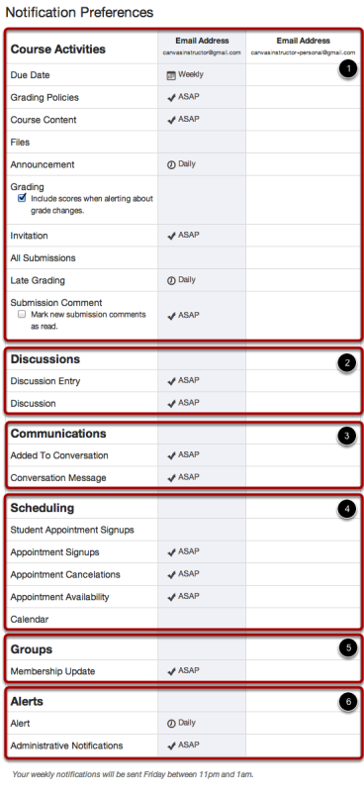](http://guides.instructure.com/s/2204/m/8472/l/73162-how-do-i-set-my-notification-preferences/show_image?image_id=2098973)

1. Course Activities
2. Discussions
3. Communications
4. Scheduling
5. Groups
6. Alerts

Below is an example of what the weekly notifications note will look like. It will give you a day and time when they will be sent. This varies between users.

[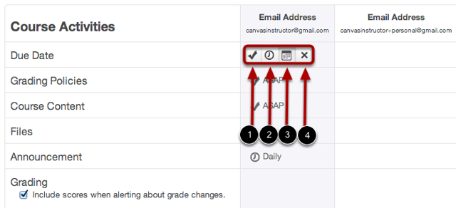](http://guides.instructure.com/s/2204/m/8472/l/73162-how-do-i-set-my-notification-preferences/show_image?image_id=2098979)

To set Notification Preferences, hover over a cell, four icons appear.

1. By selecting the **Checkmark** icon, you will be immediately notified of any change for the activity.
2. By selecting the **Clock** icon, you will be notified daily of any change for the activity.
3. By selecting the **Calendar** icon, you will be notified weekly of any change for the activity.
4. By selecting the **X** icon, you will remove the notification preference and will not be notified of any change for the activity.

**Note:** Each set notification preference will apply to all of your courses.

[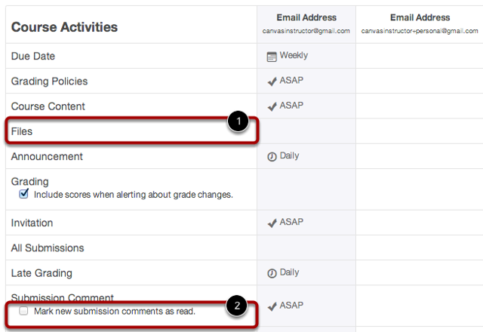](http://guides.instructure.com/s/2204/m/8472/l/73162-how-do-i-set-my-notification-preferences/show_image?image_id=2098982)

IMPORTANT things to know about notifications:

* The Salve email account is the default for all users
* Students cannot delete their Salve email account, but can add additional accounts for notifications
* Default settings for Announcements and Conversations is to notify immediately, but users can change this.
* You need to communicate to students if you will be using these tools to regularly communicate with them and inform them that they are responsible to set their notifications to receive your communications or to log in on a daily basis to check the course.

ACTIVITY: SET YOUR PERSONAL NOTIFICATIONS

1. Access your settings
2. Change Due Dates and Grading Policy Changes to Never
3. Change All Submissions to Daily
4. DO NOT CHANGE any settings to Conversations
5. Change Administrative Notifications (under Alerts) to Never
6. Change any other settings as you would like
7. **Using Commons to Import the Basic Template Into Your Section**

Canvas Commons is a place to store and share educational materials created in Canvas, such as assignments and their attached rubrics, discussion questions, quizzes, videos, pages, modules, and even entire courses. This is known as a Learning Object Repository.

# The Commons agreement

Here is a basic summary of the agreement. In your packet is a bullet point summary of each paragraph of the agreement. We have a full copy of the agreement in the CTL if you would like to read it.

You retain ownership of any materials you upload. You allow Instructure to display the materials and other Canvas users to see them and use them according to the sharing and copyright settings that you choose. You may use the materials in the system based upon the sharing and copyright settings provided by the owner of the materials.

The system is designed around the concept of sharing and open educational resources. Use at your own risk. Instructure provides no warranties about the safety or security of your materials. You agree not to sue Instructure if the system crashes and you lose your materials, or if someone else uses your materials without your permission or giving you credit. There is a copyright infringement procedure for reporting violations of copyright. Repeat offenders will be terminated from the system.

# Canvas Commons Terms of Usage in Plain English

1. We will notify you of any changes to these terms
2. This site is protected by copyright law and we are granting you limited rights to it
3. We created this software. You may not copy, reverse engineer, hack, or otherwise try to destroy or profit from it.
4. You have to register to use this site. Your Canvas login is best.
5. Whoever uploads content is responsible for that content. Canvas is not obligated to pre-screen content or to prevent deletion of content.
6. Canvas owns the software; you own your own content.
7. You give Canvas the right to display your content. You give other users a limited license to copy, modify, and redistribute the content based on the terms you assign at upload. You warrant that you have the legal right to share the content.
8. Don’t post content which is illegal, defamatory, obscene, or in violation of copyright laws. Don’t post materials to advertise goods and services.
9. Any feedback you provide belongs to Canvas to use as they wish.
10. Use all content and interact with other users at your own risk.
11. If there is a link to a 3rd party website, you access the site at your own risk.
12. Canvas is not responsible for losses arising from your content or inability to use the system.
13. There is no warranty. Use at your own risk.
14. We have a procedure for reporting copyright infringement. Those who repeatedly infringe copyright will have membership terminated.
15. Terms begin as soon as you click Accept.
16. We are an international company, so we and you have to abide by export laws.
17. You and your heirs won’t hold us liable or sue us.
18. You can’t transfer your rights. We are not responsible for acts of God. Any disputes will be handled in the courts of the State of Utah.

**Accessing Commons:**

1. Click on Commons on the upper left corner of the screen



1. Click Login

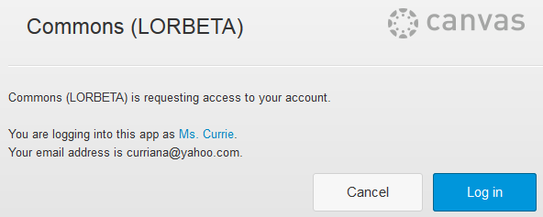

1. Scan the Terms of Use Screen and Click I Agree.

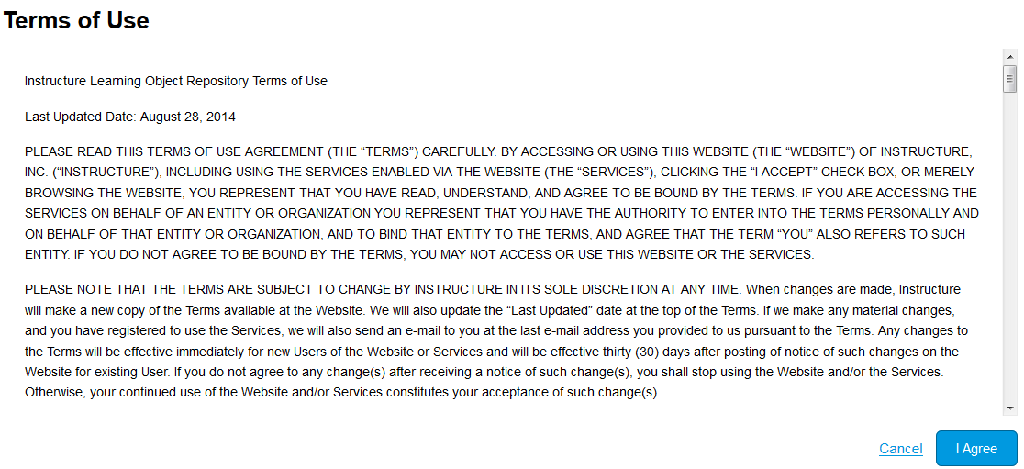

1. Hover your mouse over Courses and Groups and select your Course.

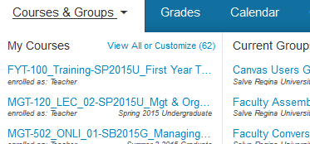

1. Click on the Import from Commons button on the right side of your course screen.

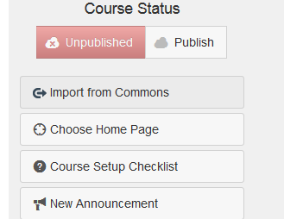

1. Click in the Search Box and type *Basic Template_NEW*.



1. Click on the Course Icon.

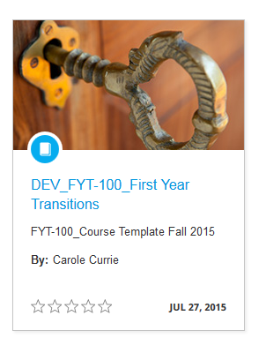

1. Click the Import into Course button on the right side of the screen and click on your target course section.

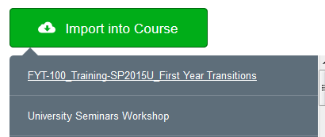

1. The following message will appear as the import is processing.



1. Wait a few minutes and then hover over Courses and Groups and select your course from the list.



1. If the Import is complete, you should see the home page of your course.

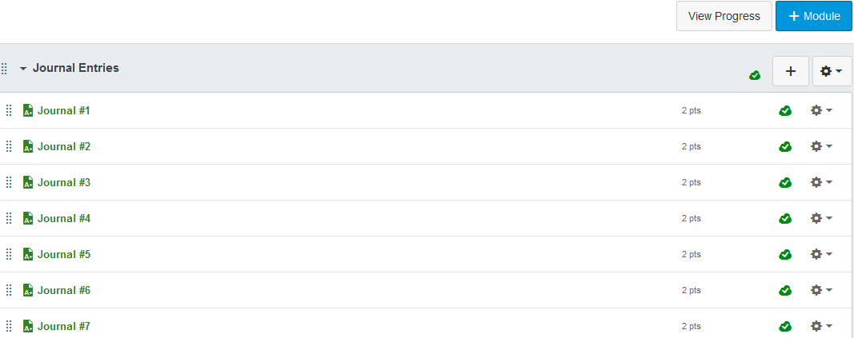

**Note**: To check that the import is complete, click on Settings on the lower left corner of your course screen and then Import into your Course on the right. You should see the record of the import with the date and time.

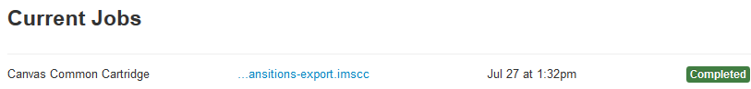

1. **Accessing a Course and Course Navigation**

You may access a course you are assigned to or enrolled in from the Courses Drop Down menu on the Global Navigation bar. Enter the desired course by clicking on the course name.

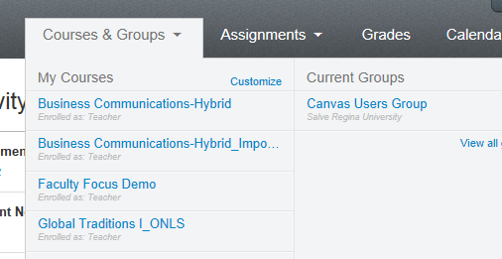

**Global Navigation Menu**

The Global Navigation menu helps you get to where you want to go across all of the Canvas courses you are enrolled in.

[Global Navigation Menu](http://guides.instructure.com/s/2204/m/4152/l/40307-how-do-i-navigate-a-canvas-course/show_image?image_id=2102991)

**Help Corner**

The Help Corner helps students contact the instructor or Canvas Support. It also provides places for user feedback and user ideas.

[Help Corner](http://guides.instructure.com/s/2204/m/4152/l/40307-how-do-i-navigate-a-canvas-course/show_image?image_id=2102994)

**Breadcrumbs**

[Breadcrumbs](http://guides.instructure.com/s/2204/m/4152/l/40307-how-do-i-navigate-a-canvas-course/show_image?image_id=2102997)

The Breadcrumbs appear above the main body of the page. Breadcrumbs leave a trail that helps you see where you have navigated to inside a Canvas course. Follow these links backward to visit parent pages. Click on the house icon at the far left of the Breadcrumbs to move all the way back to the Dashboard.

**Content Area**

The content of the course will be displayed in the Content Area. The content can be a page, the syllabus, discussions, announcements, quizzes, or imported content.

**Sidebar**

[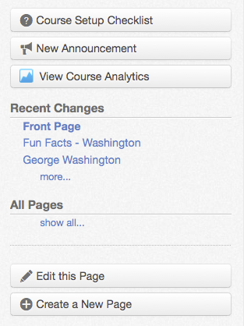](http://guides.instructure.com/s/2204/m/4152/l/40307-how-do-i-navigate-a-canvas-course/show_image?image_id=2103003)The Sidebar provides the tools available for the Canvas feature you are currently using. The Sidebar will change dynamically as you use different tools in a feature as well as when you move from feature to feature.

**S**

1. **The Syllabus**

Canvas has a built in Syllabus. There is a link to the Syllabus on the Home page. There are three main parts to the syllabus: a syllabus description, a calendar and grading scheme and a dynamic schedule automatically managed by Canvas.

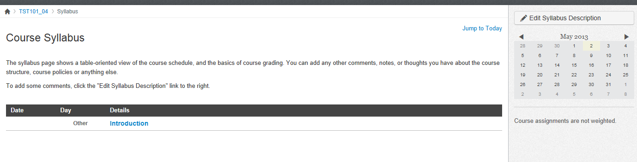

**Activity: Edit the Syllabus Description**

In this activity you will add text and upload a syllabus file to the Syllabus Description section.

1. Click the **Syllabus** link within the course you would like to edit.

[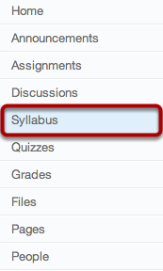](http://guides.instructure.com/s/2204/m/4152/l/41537-how-do-i-edit-the-syllabus-description/show_image?image_id=2191283)

1. Click the **Edit Syllabus Description** button.

[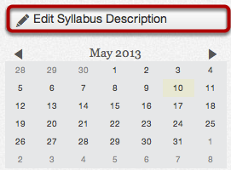](http://guides.instructure.com/s/2204/m/4152/l/41537-how-do-i-edit-the-syllabus-description/show_image?image_id=2191285)

1. Type in some introductory information to the course in the text editor box. Then type, “Click on the link to the right of this sentence to download a complete and printable copy of the course syllabus.”

**Note**: Do not cut and paste your entire syllabus into the Syllabus Description area followed by a link to the complete syllabus file. The students will not be able to print this out and they will not be able to see the schedule of activities, discussions, and assignments in the Syllabus table without scrolling down the screen.

[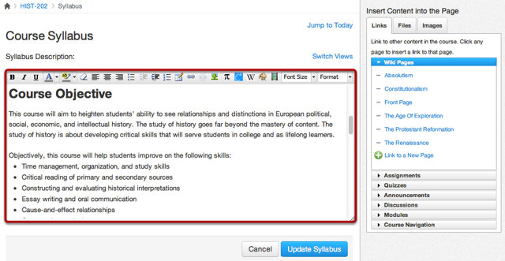](http://guides.instructure.com/s/2204/m/4152/l/41537-how-do-i-edit-the-syllabus-description/show_image?image_id=2191288)

1. Type two spaces after the sentence instructing students to click on the link to the syllabus.
2. Click the **Files** tab under Insert Content into the Page.

[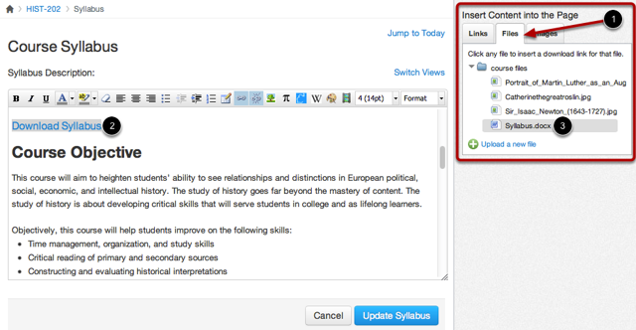](http://guides.instructure.com/s/2204/m/4152/l/41537-how-do-i-edit-the-syllabus-description/show_image?image_id=2191291)

1. Click **Upload a new file.**
2. Click **Browse** locate the syllabus file and click on it.
3. Click **Open**.
4. Click **Upload.**

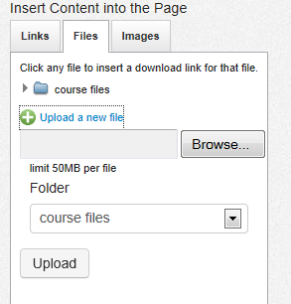

You should now see the file name and link at the location of your cursor.



1. Click **Update Syllabus**.

[Update Syllabus](http://guides.instructure.com/s/2204/m/4152/l/41537-how-do-i-edit-the-syllabus-description/show_image?image_id=2191294)

**NOTE:** The file will link wherever your cursor is located. Make sure to set your cursor in the correct position before linking to a file.

1. **Modules**

Modules are used to organize course content by weeks, units, or whatever organizational structure works for your course. With modules, you are essentially creating a one-directional linear flow of what you would like your students to do.

The standard template has a built in module course structure to make it easy for you to enter content. You may edit, delete, or add to the pre-built structure. Click on Modules from the bottom of the Home page to see the built in structure. Modules can be rearranged by Dragging and Dropping to a new location.

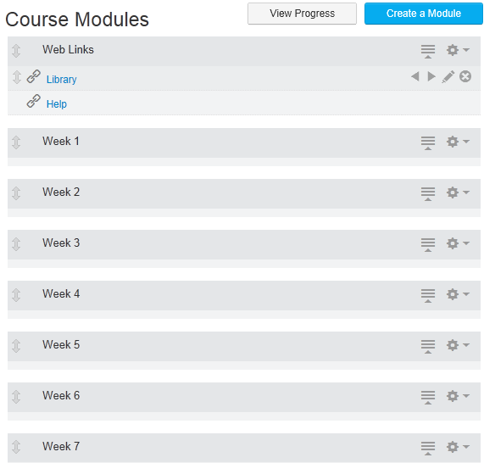

Click, hold, and drag and drop any of the double headed arrows next to the module name to move to a new location.

**Adding, Deleting, and Modifying Content in the Modules**

Every Module has a Show/Hide tool which allows you to collapse and un-collapse the module contents and a drop down tool which gives you the option to add content, edit existing content or delete the entire module. These appear on the right hand side of the module tab.

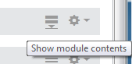 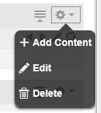

**Adding Content to a Module**

A variety of file types may be uploaded to a module including, Word, Excel, Powerpoint, audio, video and image files.

Activity: Adding a page to the Week 1 – Module

1. Click on the drop down arrow next to the gear icon of the Week 1 Module, select **Add Content**.
2. Select **Content Page**.

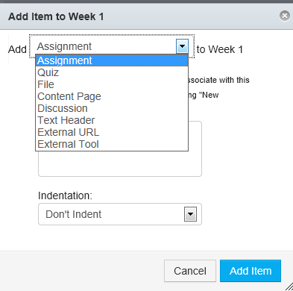

1. Click **Add Item**.
2. Click on **New Page**.
3. Type “*Overview and Task List”* into the **Page Name** box.
4. Click **Add Item**.
5. Click on the **Overview and Task List** page name to open it.

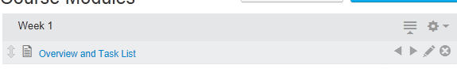

1. Click **Edit this Page** from the side bar.
2. Click in the text editing box and type the following:

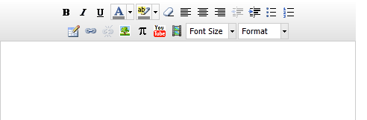*“This week we will gain knowledge of the basics of course design by completing the following tasks:”*

1. Press Enter twice.
2. Click on the Button icon on the Text Editing tool bar.



1. Type “*Task one”*, press enter, “*Task two”*, press enter, and “*Task three”*.
2. Click **Save Changes**.

Activity: Uploading Files to the Week 1 - Module

1. Click on the drop down arrow next to the gear icon of the *Week 1* Module and select **Add Content**.

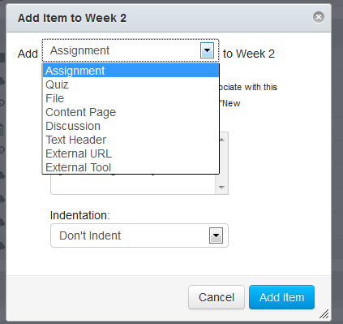

1. Click on the drop down arrow next to the *Add* box and select the ***File*** option.
2. In the middle box, scroll down to the **[New File]** option in the list and select it.

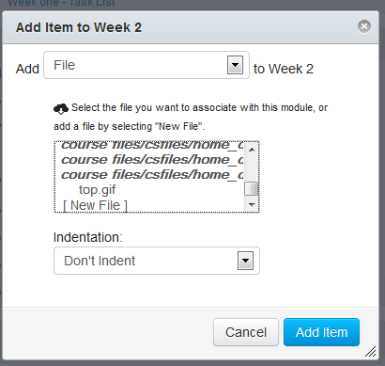

1. Click the **Browse** button, go to the folder containing your files and click on the desired file.
2. Click **Open**.
3. Click **Add Item**.

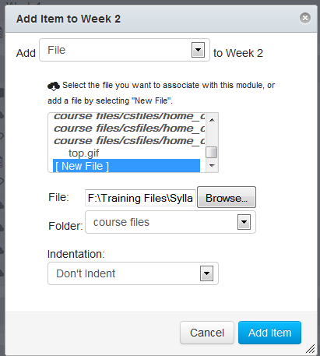

Your file should now appear as a link within the Module.



Activity: Adding a Web Link to a Module

1. Click on the drop down arrow next to the gear icon of the Week 1 Module, select **Add Content**, scroll to the **External URL** option and click on it.

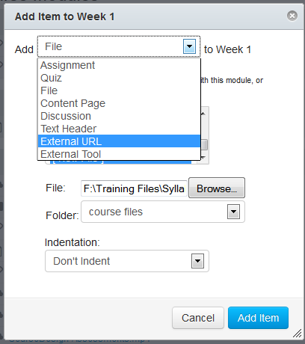

1. Type “*ctlblog.salvereginablogs.com”* in the **URL:** text box and type “*Center for Teaching and Learning Blog*” in the **Page Name:** text box.

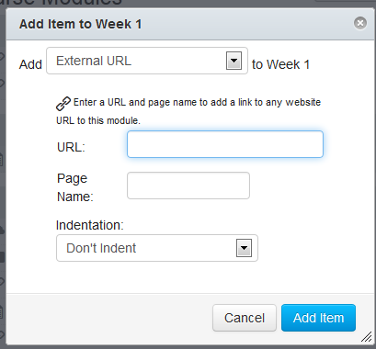

1. Click **Add Item**.

The link to the CTL appears in the Module list.



Activity: Editing Module Settings

To modify a module name and lock it until a given date:

1. Click on the Drop Down arrow next to the gear icon of the Week 1 Module and select the **Edit** option.

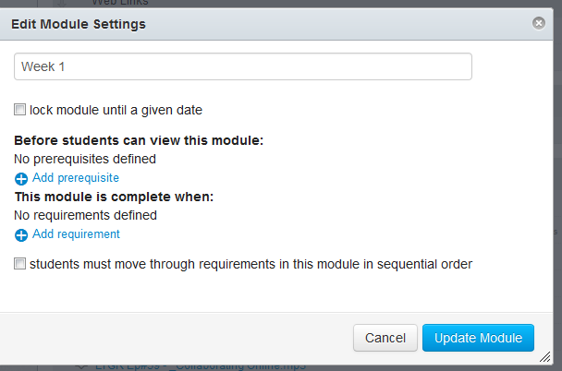

1. Click after the *1* in *Week 1* enter a “*space – Basics of Course Design”*.
2. Click the Check Box next to *lock module until a given date*.

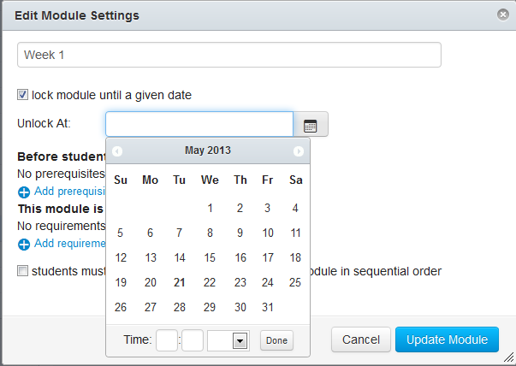

1. Select the desired date to release the Module from the calendar.
2. Click **Update Module**. The changes will be reflected in your course module.



**Note:** The students will see the name of the module, the release date, and the module links; however the module links will not activate for them until the module unlock date.

**To Create a Module**

Use the following steps for creating a module if you wish to add to the modules provided through the Standard Template import

1. Click the **Create a Module** button.

. [Create a Module](http://guides.instructure.com/s/2204/m/8472/l/41424-how-do-i-create-a-new-module/show_image?image_id=2103280)

1. Type a Module name in the name field.

[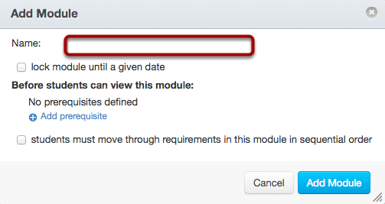](http://guides.instructure.com/s/2204/m/8472/l/41424-how-do-i-create-a-new-module/show_image?image_id=2103283)

1. Select the **Lock module until a given date** checkbox [1] to lock the module until a set date. Select the **Calendar** icon [2] to set the date and time. (Optional)

[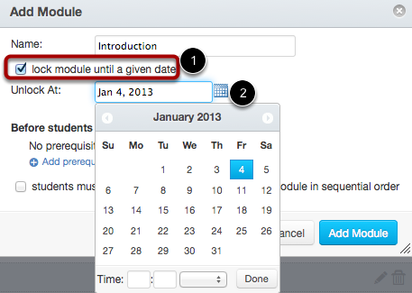](http://guides.instructure.com/s/2204/m/8472/l/41424-how-do-i-create-a-new-module/show_image?image_id=2103286)

**To Delete a Module**

Use the following steps to delete a module or modules.

1. Click on the Drop Down arrow next to the module gear and select **Delete**.

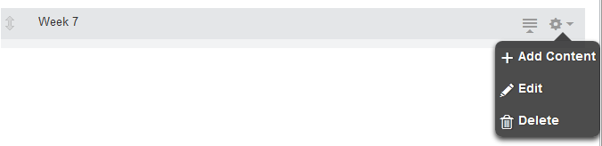

1. Click **Ok**.

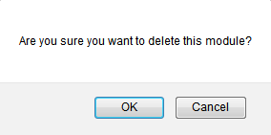

1. **Assignments**

The different assignment types in Canvas include:

Assignments Creates a Canvas assignment that can be submitted online through text entry, file uploads, media recordings, Google Docs, URLs, or Canvas pages. This assignment will show up in the Gradebook, on the Syllabus page, and on the Dashboard.

Discussions Creates a Canvas assignment that will grade student response to discussion topics. This assignment will show up in the Gradebook, on the Syllabus page, and on the Dashboard.

Quizzes Creates a Canvas assignment that can be used to conduct a survey or assess a student's comprehension of course content. This assignment will show up in the Gradebook, on the Syllabus page, and on the Dashboard.

External Tools Creates an assignment that utilizes LTI technology to link to a third-party application or website. This assignment will show up in the Gradebook, on the Syllabus page, and on the Dashboard.

Not Graded Creates a Canvas assignment with a due date, but no points or grades will be given for completing the assignment. This assignment will show up on the Syllabus page and the Dashboard.

Activity: Create an Assignment

You can create an Assignment shell on the Assignment page. Assignment shells are placeholders for the Assignment until you fill in the Assignment details.

1. Click **Assignments** in the Course Navigation.
2. Click the **plus** icon in an Assignment group header [1] or the **Add Assignment to** link [2] to create an assignment shell.

[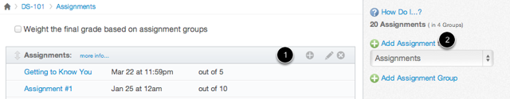](http://guides.instructure.com/s/2204/m/8472/l/41283-how-do-i-create-an-assignment-shell-on-the-assignments-page/show_image?image_id=2103337)

1. Enter the Assignment title in the first field [1].
   1. Type: *Assignment 1 - Best Practices Summary.*
2. Click the **Calendar** icon to select a due date [2] or manually enter a due date, and enter the number of points for the assignment in the points field [3].
   1. Select a due date one week from today.
3. Set the Assignment type by selecting the type drop down menu [4].
   1. Select Assignment.
4. Click **Update** to save the Assignment shell [5].

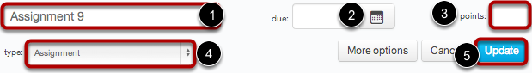

1. [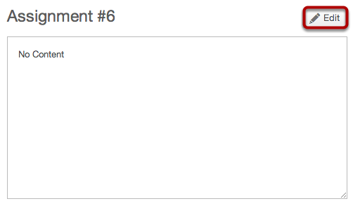](http://guides.instructure.com/s/2204/m/8472/l/41283-how-do-i-create-an-assignment-shell-on-the-assignments-page/show_image?image_id=2103346)To add more details to the assignment, click on the Assignment title and select **Edit**.
2. Enter the Instructions in the Rich Content Editor box:
   1. *“Prepare a two page summary of best practices that can take course from good to exemplary status. A successful submission must include at least three (3) citations.”*
   2. Enter “100” in the **Points** text box.
   3. Click on Advanced Options
   4. Click the Drop Down arrow next to **Submission Type** and select **Online**.
   5. Check the Allow **File Uploads** checkbox option.

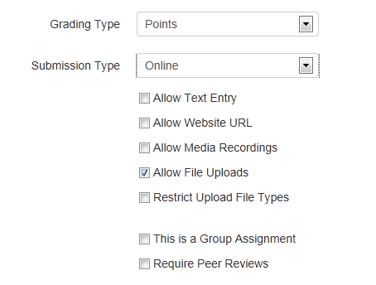

1. Click **Update Assignment**.

Activity: Create a Discussion Question

1. Click on Discussions on the Navigation Menu.
2. Click the **+ Discussion** button.



1. Enter your topic title in the topic title field:
   1. Type: *“Netiquette Guidelines Discussion”*
2. Use the [Rich Content Editor](http://guides.instructure.com/s/2204/m/4152/c/23863) to format your content.
   1. Type: “What Netiquette discussion guidelines do you think should be outlined for students in an online course?”
3. You have several options for discussions:  
   --Attach a File

--Allow threaded replies  
--Delay Posting  
--Users must post before seeing replies  
--Enable podcast feed  
--Use for grading

1. Create a threaded reply by clicking the **Allow threaded replies** checkbox.
2. Require users to post to the discussion before viewing other replies by clicking the *“****Users must post before seeing replies”*** checkbox.
3. Create a graded discussion by clicking the **Graded** checkbox.
4. Enter “100” in the Points possible box.
5. Click the Calendar icon and select a due date one week from today.

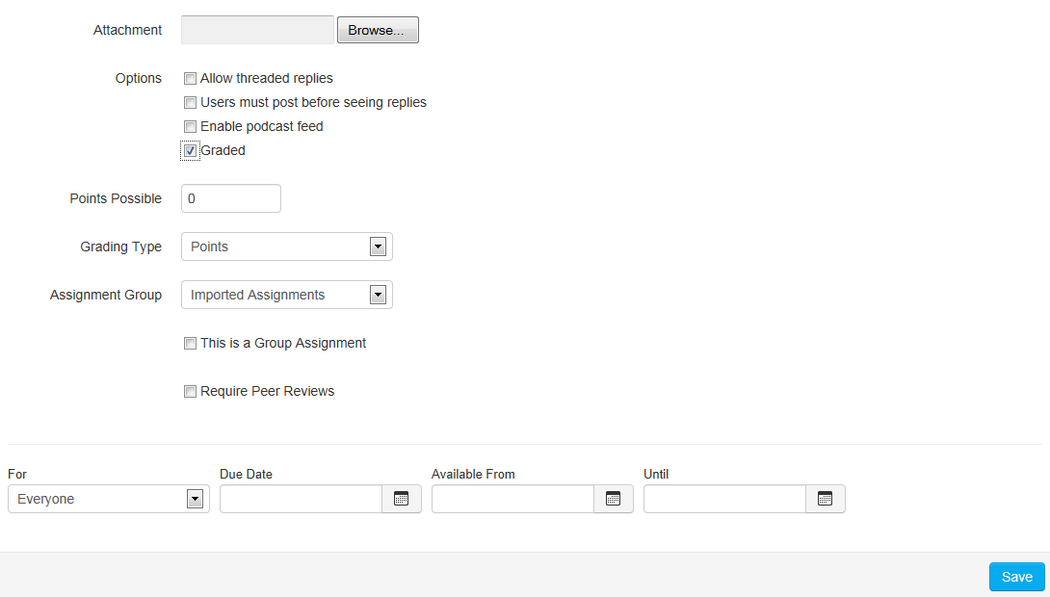

1. Click Save.

Activity: Link an Assignment and a Discussion to a Module

**To Link an Assignment to a Module:**

1. Click on the drop down arrow next to the gear icon of the Week 1 Module and select **Add Content**.
2. Select **Assignment** from the **Add** drop down list.
3. Click on the *Assignment 1 – Best Practices Summary* from the **Assignments** list.

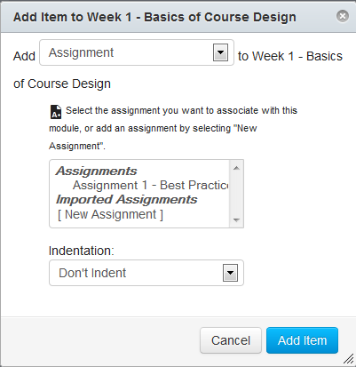

1. Click **Add Item**. The assignment will appear in the Module.



**To Link a Discussion to a Module:**

1. Click on the drop down arrow next to the gear icon of the Week 1 Module and select **Add Content**.
2. Select **Discussion** from the **Add** drop down list.
3. Click on the *Netiquette Guidelines Discussion* from the list.

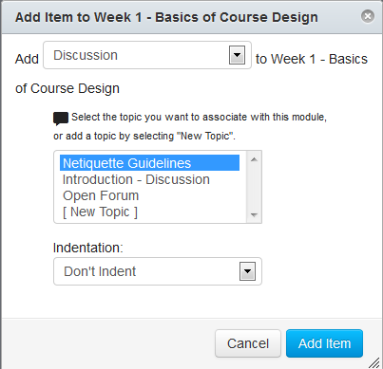

1. Click **Add Item**. The discussion will appear in the Module.



1. **The Calendar**

The Calendar automatically syncs with other features in Canvas, such as Assignments, Syllabus, and Grades, so if you create, change or delete the due date of an Assignment on the Calendar, it will show up in all the others and vice versa. The Calendar in Canvas is a global feature, meaning you can see all of your assignments from all of your courses in one place. If your Calendar becomes too crowded, you can filter the number of events listed on your Calendar by selecting or deselecting courses in the Sidebar on the right.

To view the Calendar, click the **Calendar** link on the Global Navigation Bar.



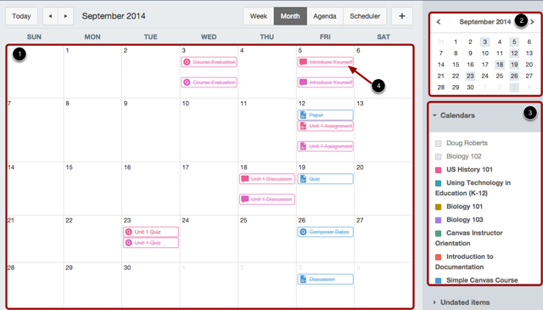

After clicking on the Calendar link, you will see the Calendar Month with the events [1], the mini

Calendar [2], and the Calendars for courses and/or groups [3].

You can use the Calendar to:

• quickly add Assignments to a blank course. Fill in the details of those Assignments later.

• adjust the dates of Assignments that have been imported from previous terms. Canvas makes it easy to drag and drop events across multiple months.

• copy the iCal feed for all of your courses and add it to your preferred personal Calendar.

1. **Accessing Student View**

You can view your course from the view of a student. You can grant yourself this access in your course Settings.

The Student View feature creates one "Test Student" user that allows the instructor to view course content as a student would. Each course has a unique Test Student that every instructor in the course has access to.

You can use Student View to:

• View the course

• Post to a Discussion

• Turn in an Assignment

• View Grades

• View People

• View Pages

• View the Syllabus

• View Quizzes

**Please note**: There is a separate Test Student account for each course in Canvas. Whenever you move to a new course you will need to activate the Test Student for that course. As the Test Student, you can submit Assignments, post to Discussions, and see the course as a student.

You can also Reset the Test Student to clear the Test Student's history and re-check content in the course. For example, an instructor created an assignment, submitted it as the Test Student, but realized he or she forgot to add a certain submission type. The instructor can click on the Reset Student button and submit the assignment again as the Test Student.

Remember, Conversations, Collaborations, and viewing the Profile do not work for the Test Student. You will see only what you, as the instructor, allow your students to see. Also, the Test

Student has been removed from results averages.

**To Access Student View:**

1. Click the **Settings** link on the Course Navigation Bar.



1. Click the **Student View** option at the upper right corner of the screen.

[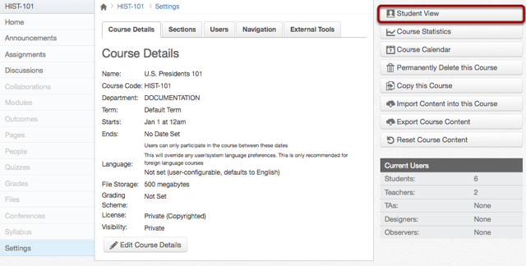](http://guides.instructure.com/s/2204/m/4152/l/61153-how-do-i-access-student-view/show_image?image_id=2150136)

You can now view the course as a student user would see it. For example, students cannot see the Settings navigation link like instructors can.

**Note**: You will know if you are in Student View because of the persistent bar on the bottom of the screen indicating you are logged into Student View.

[Leave Student View](http://guides.instructure.com/s/2204/m/4152/l/61153-how-do-i-access-student-view/show_image?image_id=2150146)

You can leave student view by clicking the **Leave Student View** button [1].

You can also reset the Test Student by clicking **Reset Student** [2]. This will clear all history for the student allowing you tstart with a clean slate.

Activity: Use Student View to Submit an Assignment

1. Click on *Assignments* link from the Menu Bar of the course, you will see all the Assignments for that course.
2. Click on the Assignment title. You will see a screen with assignment instructions.
   1. *Click on Assignment 1 – Best Practices Summary.*
3. Click **Submit Assignment** to submit your work.  
   Assignment may be submitted as a File Upload, Text Entry, Website URL, or Media depending on what the instructor allows. For this exercise we will submit as a File Upload.

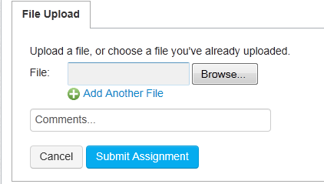

1. Click **Browse**, locate the assignment file.
2. Click **Submit Assignment**.
3. After you have submitted your work, you will see information in the Sidebar about your submission.

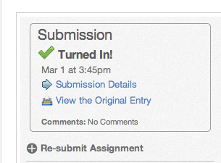

If you choose, you may resubmit another version of your assignment using the **Re-submit Assignment** link. You will only be able to view the details of your most recent submission in the Sidebar, but your instructor will be able to see all of your submissions.

Once the instructor has graded your submission, you will be notified via the channels that you specify in your Notification Preferences.

You can also see details about your assignment and links to additional feedback in the Gradebook.

Activity: Use Student View to Respond to a Discussion

1. Click on **Discussions** from the **Course Navigation** bar.
2. Click on the discussion **Netiquette Guidelines**.
3. Click on the word **Reply** in the text box.

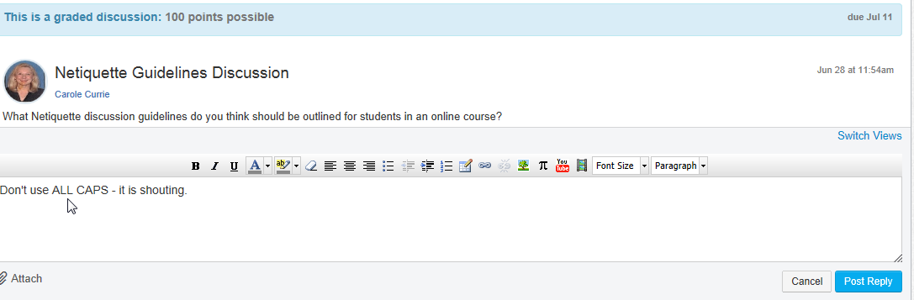

The Rich Content Editor will appear and you may type your message.

1. Type one Netiquette tip in the text box and click **Post Response**.

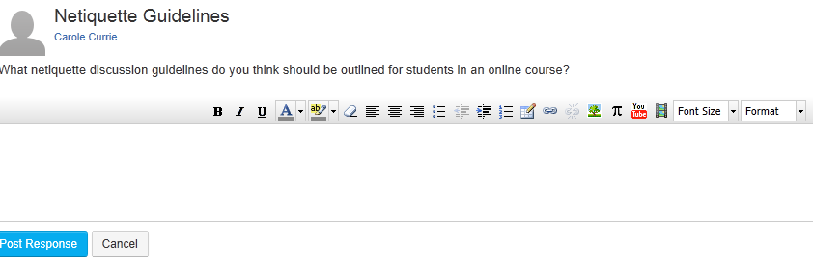

1. **Speed Grading Assignments**

The SpeedGrader™ allows you to view different types of assignment submissions in one place, make text and audio comments to students, and grade using different methods including a simple point scale or a complex rubric.

Canvas accepts a variety of document formats and even URLs as assignment submissions. SpeedGrader™ will automatically convert .doc, .docx, .xls, .xlsx, .ppt, .pptx, and .pdf using [Crocodoc](http://guides.instructure.com/m/4152/l/80119-how-do-i-use-crocodoc-in-the-speedgrader), while the rest of the file formats will be converted using either Scribd or Google Preview.

Within one frame, you can view [1], grade [2], start discussions [3], and provide students with written, video, and audio commentary [4]. Your private feedback to the student, through text, audio, or video, will be sent via the communication channels that they prefer.

When you have finished with the first student, you can see the submission from the next student by clicking the arrow button [5].

[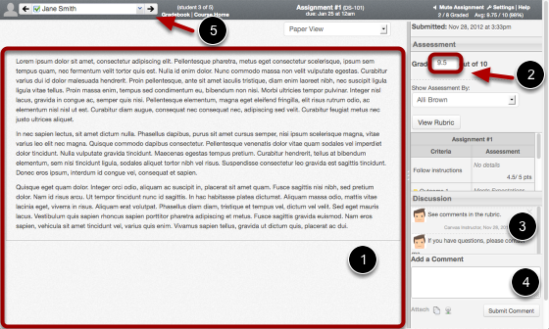](http://guides.instructure.com/s/2204/m/4152/l/55016-what-can-i-do-with-speedgrader/show_image?image_id=2103447)

When you open SpeedGrader™ for a particular assignment, you will see each individual submission, the date and time that it was submitted [1], and a red notification if the assignment was submitted after the due date [2].

[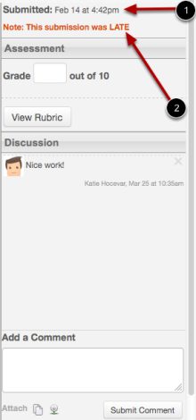](http://guides.instructure.com/s/2204/m/4152/l/55016-what-can-i-do-with-speedgrader/show_image?image_id=2103450)

Activity: Grade and Evaluate an Assignment in Speed Grader:

1. Click the **Assignments** link.
2. Click the assignment title you want to view.
   1. *Click on Assignment 1 – Best Practices Summary*

[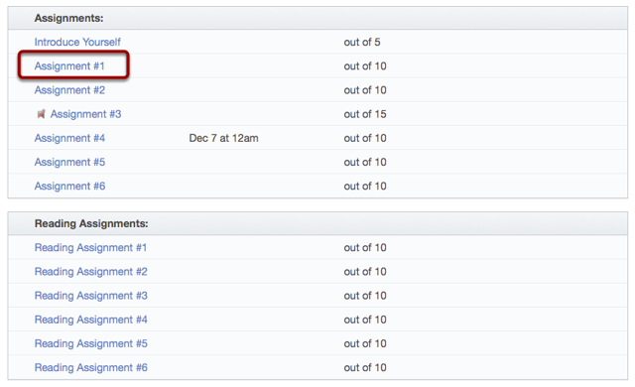](http://guides.instructure.com/s/2204/m/4152/l/55021-how-do-i-evaluate-an-assignment-in-speedgrader/show_image?image_id=2148859)

1. Click the **SpeedGrader™** link.

[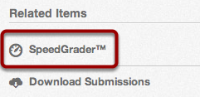](http://guides.instructure.com/s/2204/m/4152/l/55021-how-do-i-evaluate-an-assignment-in-speedgrader/show_image?image_id=2148864)

You can evaluate an assignment by entering a grade in the grade field [1]. You can also click the **View Rubric** button [2] and use the rubric to evaluate the assignment, if there is a rubric attached to the assignment. If you would like to submit a comment on the evaluated assignment, type in the **Add a Comment** field [3]. You can also attach a file or a media comment by clicking one of the Attach icons [4]. When you are ready to submit your comment, click the **Submit Comment** button [5].

1. Type a numeric **Grade** in the text box.
2. Type a Comment in the **Add Comment** field and click **Submit Comment**.

[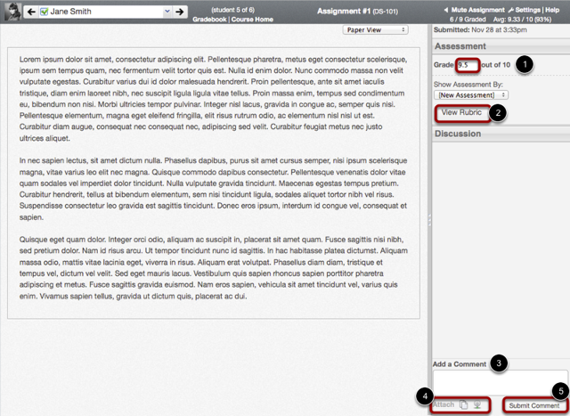](http://guides.instructure.com/s/2204/m/4152/l/55021-how-do-i-evaluate-an-assignment-in-speedgrader/show_image?image_id=2148868)

**How do I use Crocodoc in the SpeedGrader™?**

Crocodoc is a tool that allows teacher and peer review annotations on submissions of online assignments in Canvas. When you submit an assignment, the file is uploaded as a submission and to your personal file repository. If Crocodoc cannot convert a submission, Scribd or Google Preview will convert it, depending on the preview tool you use. Crocodoc supports .doc/.docx, .ppt/.pptx, .xls/.xlsx (in beta), and .pdf file formats. Crocodoc tools will be available to use with supported file types.

**Note**: Files over 100MB and password protected files will not be converted by Crocodoc.

**View Crocodoc Tools**

[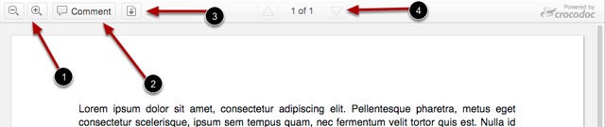](http://guides.instructure.com/m/4152/l/80119-how-do-i-use-crocodoc-in-the-speedgrader/show_image?image_id=2149369)

1. The **Magnifying Glass** icon allows you to zoom in and out on the submission.
2. The **Comment** icon opens the commenting tool in order to add comments on the submission.
3. The **Download** icon allows you to download the submission file and/or the annotated submission file.
4. The **Page arrow** icon helps you advance through the submission to find the page you want to annotate.

**Download File**

[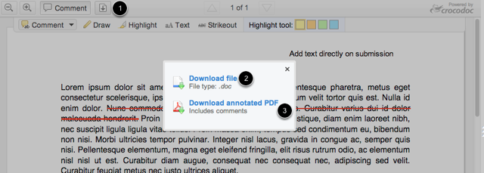](http://guides.instructure.com/m/4152/l/80119-how-do-i-use-crocodoc-in-the-speedgrader/show_image?image_id=2149396)

To download the file, click the **download** icon [1]. You can either download the original file [2], which is the original submission without your comments, or the annotated PDF file [3], which will show all your comments and/or annotations.

**Note**: When you download a Crocodoc file, it will be saved as *doc. [file format*]. For example, if a submission was *myassignment.doc*, the downloaded file will be *doc.doc*. In order to easily find the Crocodoc file in the future, it would be beneficial to rename the downloaded file on your computer.

**Student View: Submission Details**

[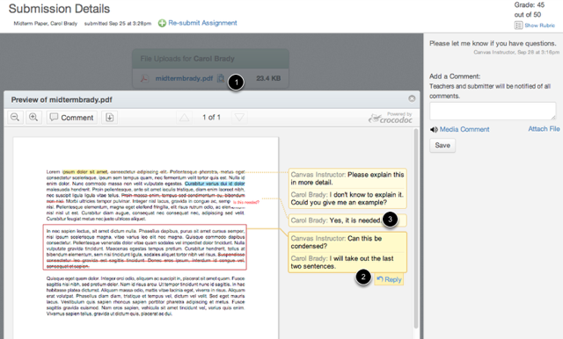](http://guides.instructure.com/m/4152/l/80119-how-do-i-use-crocodoc-in-the-speedgrader/show_image?image_id=2149399)

Students see annotations by viewing the [Submission Details](http://guides.instructure.com/s/2204/m/4212/l/54359-how-do-i-view-instructor-comments). Students need to click the preview icon [1] to view the annotations. Students can reply [2] to comments and leave other feedback [3].

**To Enter or Edit Scores in the Gradebook**

Most likely you will use the SpeedGrader to enter grades. The grades will appear in the Gradebook when you are done. However, if you want to enter or edit scores in the Gradebook, follow these steps.

1. From the Course Navigation bar, click the **Grades** link.
2. Click the assignment cell located in the row of the student whose score you want to enter.

[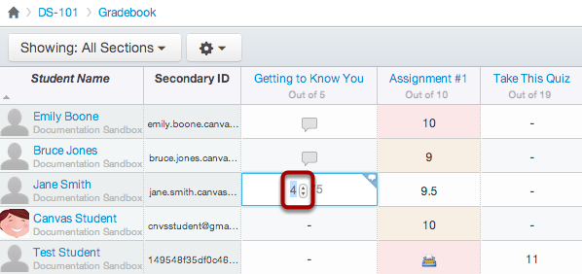](http://guides.instructure.com/s/2204/m/8472/l/54999-how-do-i-enter-and-edit-scores-in-the-gradebook/show_image?image_id=2103441)

1. Type or use the arrows to enter the new score in the cell and press Return (on a MAC keyboard) or Enter (on a PC keyboard).
2. View the new score.
3. **Communications**

**Announcements**

Announcements are simple to make in Canvas.

1. Click the **Announcements** Link from the Course Navigation menu.
2. Click the **Make an Announcement** button.

[Make Announcement Button](http://guides.instructure.com/s/2204/m/4152/l/50731-how-do-i-make-an-announcement/show_image?image_id=2129977)

1. Type a title for the announcement in the topic title field [1], add content in the Rich Content Editor [2], and click **Save** to post. The announcement is visible on the announcements page.

[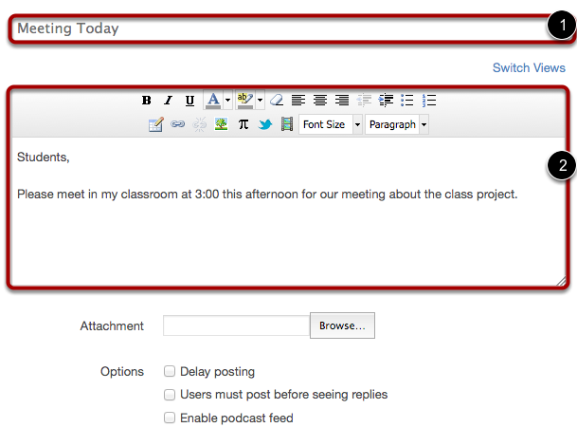](http://guides.instructure.com/s/2204/m/4152/l/50731-how-do-i-make-an-announcement/show_image?image_id=2129980)

**Conversations**

*Conversations* is a global messaging tool that allows you to communicate with ALL your Canvas courses and groups in one location. Conversations is more than just an email tool, as you can also send audio/video messages and view discussion replies. Comments made on assignments will also show in the conversation stream. Original messages and their replies are grouped together in what is referred to as a Conversation.

Click the **Inbox** link in the Help Corner to open your Conversations Inbox. The number in the blue circle shows how many new messages are in your box.

[Open the Inbox](http://guides.instructure.com/s/2204/m/4152/l/48299-how-is-my-conversations-inbox-organized/show_image?image_id=2120039)

If you right-click or option-click on the Inbox link, you can open your Conversation Inbox in a new browser tab to keep it handy while you are doing other tasks in Canvas.

**Viewing the Conversations Inbox**

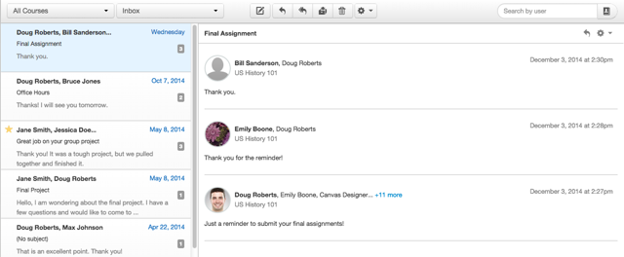

Conversations are listed on the left side [1]. All sent and received Conversations appear. The Conversations preview window is on the right side [2]. You can create and send a new message or view a selected conversation.

The Conversation Inbox is organized chronologically from newest to oldest with the newest Conversations appearing on top and the older Conversations appearing towards the bottom.

**Other Ways to View Conversations**

You can manage your view of the inbox by choosing options from the dropdown menu or by using the filter feature.

By clicking the **Inbox** dropdown menu [1], the window can show Archived Conversations, Starred Conversations, Sent Conversations, Unread Conversations, and Discussion Replies.

[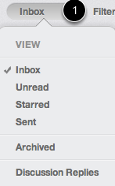](http://guides.instructure.com/s/2204/m/4152/l/48299-how-is-my-conversations-inbox-organized/show_image?image_id=2120048)

To filter your conversations, type the name of a course, group, or individual in the filter field [1], or browse for the course, group, or individual by selecting the **Address Book** icon [2].

**Note**: You can filter more than just your Inbox. You can filter your Unread, Starred, Sent, and Archived messages.

[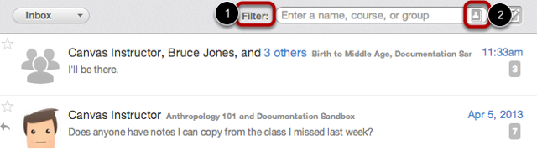](http://guides.instructure.com/s/2204/m/4152/l/42680-how-do-i-filter-conversations/show_image?image_id=2144284)

**How to Compose a Message**

1. Click the **Pencil and Paper** icon to compose a new message.

[Compose Message](http://guides.instructure.com/s/2204/m/4152/l/48305-how-do-i-compose-a-message/show_image?image_id=2120322)

1. **Type Name in the To: Field**

[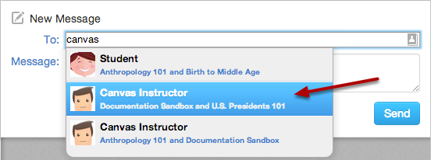](http://guides.instructure.com/s/2204/m/4152/l/48305-how-do-i-compose-a-message/show_image?image_id=2120325)

* 1. When you start typing an individual's name in the To: field, Canvas will automatically pull up matching names. If multiple names appear, use the arrow key to select the individual you want to message. Then press Enter. The individual's name will appear in the To: field, highlighted in light blue.
  2. If you accidentally select the wrong individual(s), press **Delete** (on a MAC keyboard) or **Backspace** (on a PC keyboard) to remove the name(s).
  3. You can also hover over a recipient name and click on the white x to delete it from the To: field.

1. **Use Course Roster**

[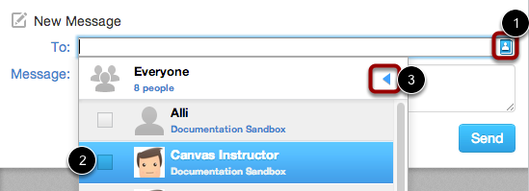](http://guides.instructure.com/s/2204/m/4152/l/48305-how-do-i-compose-a-message/show_image?image_id=2120328)

* 1. To select an individual from the course roster, click the **Address Book** icon [1] next to the To: field. From the course drop-down list, click the course name. Locate the individual and select the checkbox next to his or her name [2]. To navigate back to the list of courses, use the arrow icon [3].
  2. To exit the course roster menu, press **Return** (on a MAC keyboard) or **Enter** (on a PC keyboard).

**To message entire class or group**

1. **Select Course or Group**

[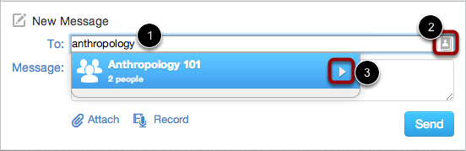](http://guides.instructure.com/s/2204/m/4152/l/92750-how-do-i-send-a-message-to-an-entire-class/show_image?image_id=2144087)

1. In the To: field [1], start typing the course name, or use the address book [2] to locate the course name. Select the arrow to open the list of students you can message [3].
2. **Select Everyone**

[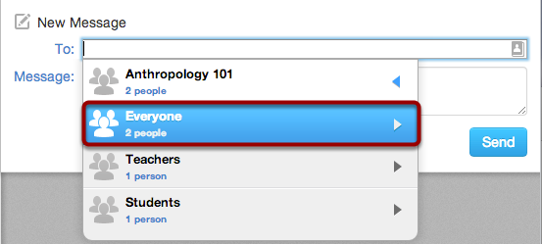](http://guides.instructure.com/s/2204/m/4152/l/92750-how-do-i-send-a-message-to-an-entire-class/show_image?image_id=2144092)

1. To send a message to everyone in the course, click **Everyone**. To exit, press **Return** (on a MAC keyboard) or **Add** Message

[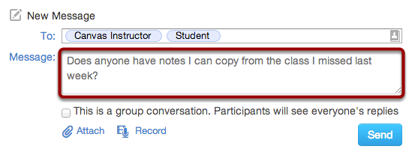](http://guides.instructure.com/s/2204/m/4152/l/92750-how-do-i-send-a-message-to-an-entire-class/show_image?image_id=2144099)

1. Type a message in the Message field.

**Create Class Conversation**

[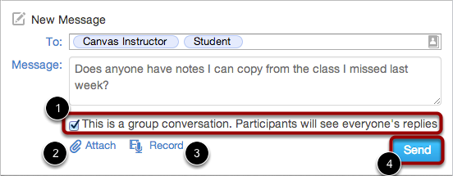](http://guides.instructure.com/s/2204/m/4152/l/92750-how-do-i-send-a-message-to-an-entire-class/show_image?image_id=2144102)

1. Select the **This is a group conversation....** checkbox [1]. To attach a file, click the **Attach** link [1]. To attach a video or audio message, click the **Record** link [3]. When you are finished, click the **Send** button [4].

Activity: Conversations

(Note: Make sure notifications in Conversations are set to ASAP during notifications activity)

1. Create a message to the person on your right in the Training Group
2. Create a second message to the entire training group. Be sure to make it a Group Conversation.
3. You should now have two conversations in your inbox. Respond once to each conversation
4. Filter your messages by the name of the person that you sent your first message to.
5. Check your Salve email box to see how the conversations appear in your external email.
6. **Choosing a Home Page**

The Course Home Page is associated with the Home link in Course Navigation and is the first page seen for each course. You can change your Course Home Page to reflect one of five layout options: the Course Activity Stream, Pages Front Page, the Course Modules, the Assignment List, or the Syllabus.

* **The Course Activity Stream** (default) lets users see the most recent activity and interactions for this course.
* **The Pages Front Page** allows instructors to design the course homepage and include links, images, or rich media.
* **Course Modules** organizes the course into modules, or sections. Modules helps outline the course and shows the assignments or tasks required throughout the course.
* **The Assignment List** shows the list of assignments for the course with upcoming and recent assignments at the top of the page. Users can click the link of the assignment to view more details.
* **The Syllabus** may include a description of course expectations or introduce the course with links, images, or other content. The Syllabus also automatically populates a calendar view of all assignments and course events as they are added or modified in the course

**We recommend that you change the Home Page to Syllabus, Modules, or Pages Front Page.**

**To change your course home page:**

* 1. In the Home Page sidebar, click the **Choose Home Page** link.  
       
     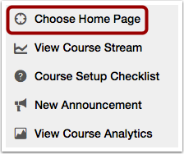
  2. Click the radio button next to the Home Page layout you prefer.  
       
     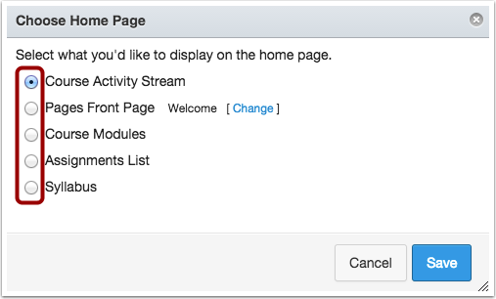
  3. If you want to select a Pages Front Page but the link is grayed out, you must first set a Front Page. Click the link to access Pages and set the Front Page.  
     **NOTE:** Only Published pages can be set as the Front Page. Make sure the page you want to set as the Front Page is published.  
       
     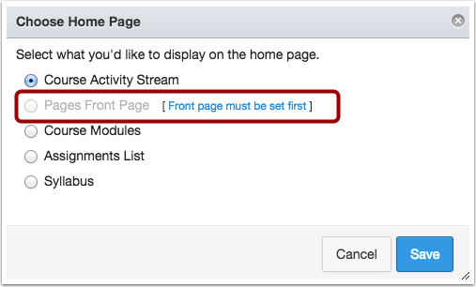
  4. Click the **Save** button.

1. **Publishing a Course**

A course will not be available to students until published.

To Publish a Course

1. Open your course and view the Course Home Page.
2. In the Sidebar, click the **Publish** button.

[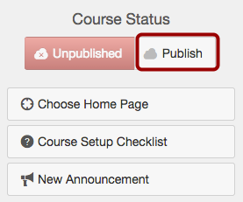](http://guides.instructure.com/m/4152/l/57126-how-do-i-publish-my-course/show_image?image_id=5175494)

1. A message will appear at the top of your screen confirming the publishing of your course.

[View Course](http://guides.instructure.com/m/4152/l/57126-how-do-i-publish-my-course/show_image?image_id=4591220)

**Note:** You can unpublish your course by clicking the Unpublish button in the Course Home Page sidebar. However, once your course contains a graded submission, you can no longer unpublish your course.

1. **Getting Help**

There are a variety of options for obtaining assistance with Canvas. Canvas provides excellent online documentation (Canvas Guides) for students, instructors, instructional designers, parents, and LMS admins Instructors. The lessons are continually updated online. The downloadable PDF manuals are updated every release.

**To Access the Canvas Guides**

1. Click the Help button from the Help Corner Bar on the upper right corner of the Canvas screen.



1. To find documentation or videos on how to use various features in Canvas, click on **Search the Canvas Guides**.

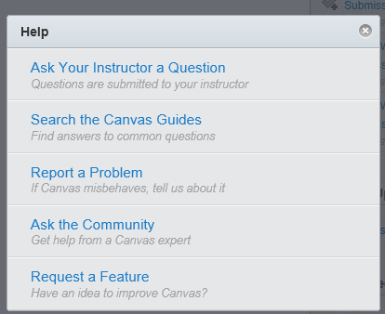

1. You will see a Search box where you can type a topic to search for or click on any of the listed links. The **Canvas Instructor Quickstart Guide** is an excellent place to start.

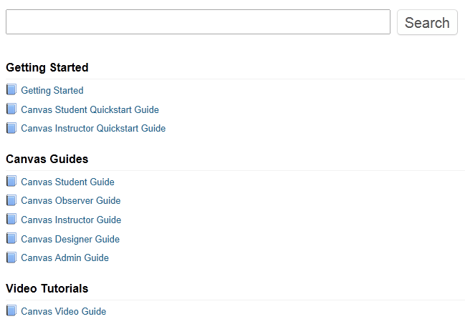

For information on how to Use the Canvas Help Center, click on **Getting Started** and click on any of the links listed under the Canvas Help Center heading.

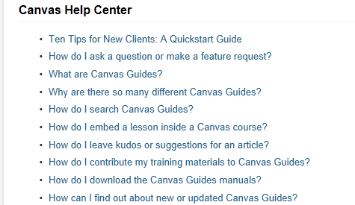

You may also contact the Salve Help Desk at 401-341-7777 or [helpdesk@salve.edu](mailto:helpdesk@salve.edu).